BULLYING & SUICIDE

“Bullies cause depression, depression causes suicide, suicide is killing, killing is murder, bullies are murderers.”
Andrew Troyer
What is Bullying?
Bullying is unwanted, aggressive behavior among school aged children that involves a real or perceived power imbalance. The repeated behavior of bullying has negative impacts towards the victim and the perpetrator which if not dealt with at an early stage may have serious lasting problems.

Causes of Bullying?
- Influence of social media e. g violent films
- Lack of school rules and implementation of justice
- Family Background
- Peer pressure
- Stress & Trauma
- Low Self-Esteem
- Gender
- Previous victims of Bullying
Most Common Types of Bullying?

- Physical Bullying
Involves hurting someone’s body possessions.

- CyberBullying

It involves a person using the internet or smartphone to threaten, harass, embarrass or target another person.

- Verbal Bullying
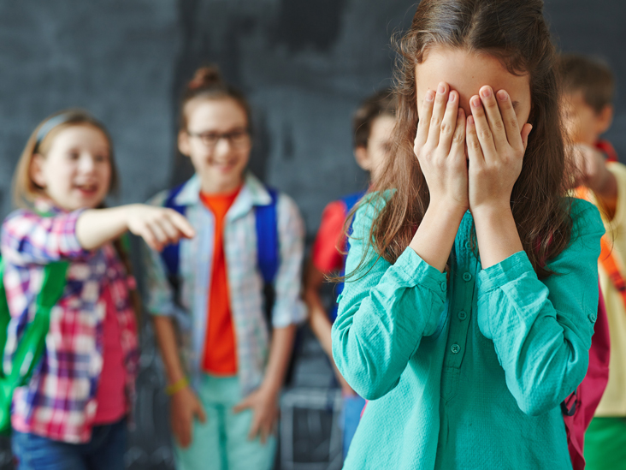

Is the use of words, statements and name-calling to gain power and control over target.

- Sexual Bullying

Consists of repeated, harmful and humiliating actions that target a person sexually.

- Relational Aggression
A type of social manipulation where the intention is to hurt another person emotionally through spreading rumors, controlling or break confidence.

Effects of Bullying?
On Perpetrators
- Students who bully are more likely to break the law.
- Perpetrators of bullying become convicted with delinquency.
- Has negative impact on social relationships with other students

On Victims
- Learners who are victimized tend to resort to drastic escape such as committing suicide.
- It can lead student to avoid going to school.
- Bullying has an impact on the learning experience of a student.
- It can cause physical illness such as depression, anxiety.

The Link Between Bullying and Suicide
Bullying is a tremendously painful experience especially for children .It can be a catalyst for suicide and its significance should not be overlooked. Bullies and victims of bullying are more likely to think about and attempt suicide. It is bad for everyone involved. Suicide is completed when the victim cannot escape the chronic effects of bullying. They cannot find a way to cope that protects and helps them to overcome their suffering. Also, the victim may fall short of seeking more social interactions. That will aid in the process of suicide.

Ways to Prevent Bullying in Schools?

- Recognizing the problem
- Providing bullying prevention protocols
- Creating a safe environment
- Implementing bullying prevention strategies in schools.
- Engaging parents

# Be a H.E.R.O. Against Bullying: Help. Educate. Report. Overcome

